Project Design Phase-II
Data Flow Diagram & User Stories

Date | 22-02-2026
Team ID | LTVIP2026TMIDS54337
Project Name | Resolve Now
Maximum Marks | 4 Marks

Data Flow Diagrams - Overview:

A Data Flow Diagram (DFD) visualizes how information flows through the Resolve Now platform, showing how users interact with the system and how data moves between different subsystems. It also identifies the data sources, storage points, and the flow of information between external actors (users, agents, admins) and the application.
The platform follows a Level-0 and Level-1 DFD model, highlighting:
- Data entry points like complaint registration
- Internal processes such as authentication, complaint assignment, and status updates
- External entities like agents/admins interacting with the system
- Storage in the MongoDB database
- This helps both developers and stakeholders understand how data travels securely and efficiently within the app.

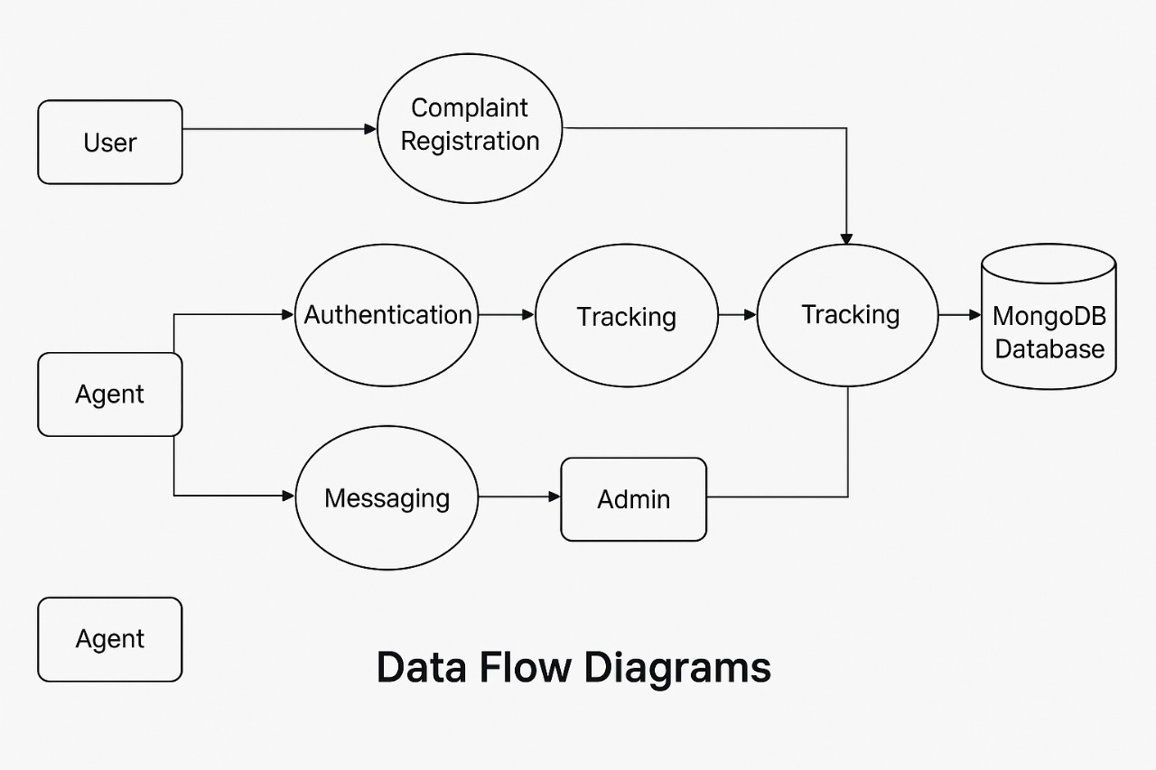

Revised user Story Table – Resolve Now
User Type | Functional Requirement (Epic) | User Story / Task | Acceptance Criteria | Priority | Release
User | Complaint  Registration | As a user, I can submit a complaint with  relevant details and attachments. | Complaint is saved and  Confirmation is shown | High | Sprint-1
Agent | Complaint  Management | As an Agent, I can view assigned  Complaints and update their status | Status change is saved and  User is notified | High | Sprint-1
User | Complaint  Tracking | As a user, I can view the status of my  Complaints in real-time | Status is displayed correctly  Ffrom the database | Medium | Sprint-2
User + Agent | Messaging/  Communication | As a user/agent, I can chat in real-time  Within the complaint thread. | Messages are visible  instantly to both parties. | Medium | Sprint-2
Admin | Complaint  Assignment &  Moderation | As an admin, I can assign complaints to  agents and review platform activity. | Assignment is reflected in  agent dashboard. | High | Sprint-1

This user story table clearly maps out the expected functionalities of each user role in the Resolve Now platform. Stories are prioritized and distributed across sprints based on complexity and user impact. High-priority features like complaint registration, assignment, and tracking are handled in the initial sprint releases to ensure a strong MVP.
Each story is tied to a specific acceptance criteria, helping developers and testers validate completion, while also ensuring alignment with user expectations.

